Project Design Phase
Solution Architecture

Date | 18 February 2026
Team ID | LTVIP2026TMIDS80016
Project Name | Flavor Fusion: AI- Driven Recipe Blogging
Maximum Marks | 4 Marks

Solution Architecture:
- The architecture follows a client-server model:
a Streamlit frontend captures user inputs (text/images) and sends requests to a Python backend. The backend utilizes Gemini 2.5 Flash Lite for generative tasks, while Google Cloud Run ensures scalable, containerized deployment and high-performance API orchestration.and delivered.

Architecture Diagram:

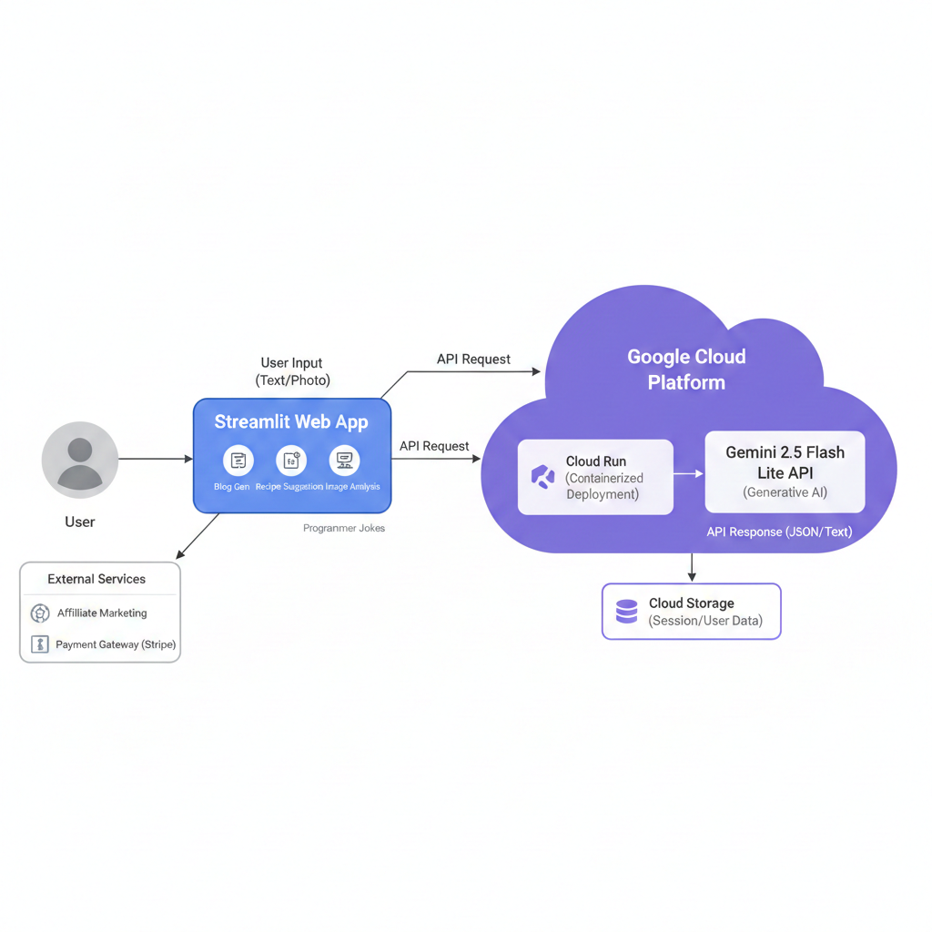
Reference:
https://docs.cloud.google.com/architecture/framework

